Carbody Structure and Exterior

Introduction

Use

Purpose

Parts List

All figures are assigned to an individual page unless views are required to show a complete listing of equipment.

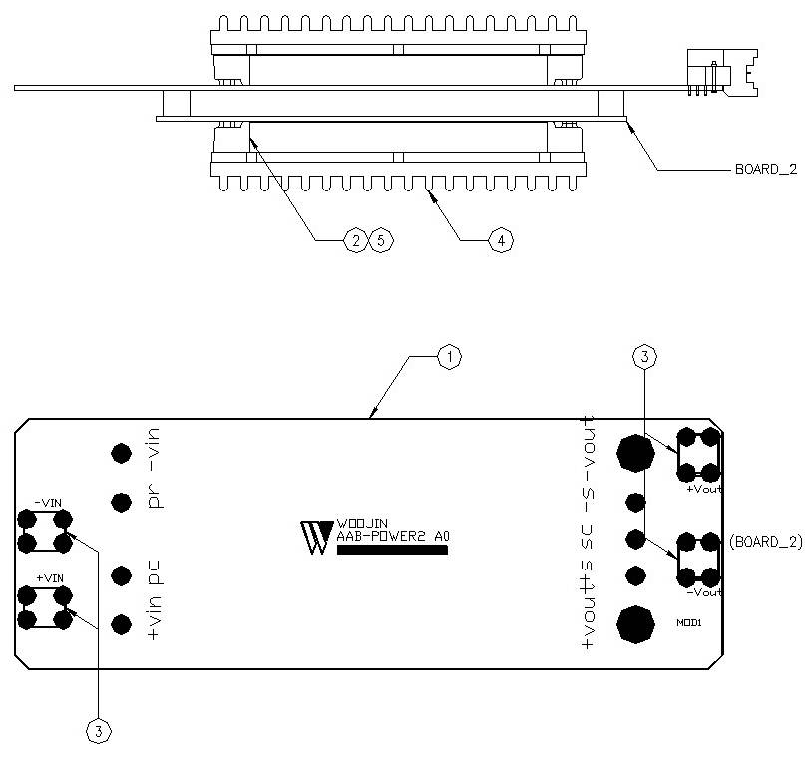

Figure 2.1. AAB Power Board2
Table 1 - Figure 2.1. AAB Power board2
FIG No. | PART NUMBERS |  |  | ITEM DESCRIPTION | VENDOR CODE | QTY
 | HRC | VENDOR | DTP
1 |  | AAB-POWER2 A0 |  | . BOARD, | HANSAEM | 1
2 |  | VI-920100B |  | . DC/DC CONVERTER | VICOR | 1
3 |  | BR111, M3.5X8 |  | . SUPPORT | BEE RYONG | 4
4 |  | AI, D116 X L55 X H9 |  | . HEAT SINK | EGPOWER | 1
5 |  | ROUND, M3 X L10mm |  | . BOLT |  | 6

